# Lesson 4: Designing an experiment

Four staps in designing an experiment

1. Choosing “subject”
2. Choosing “population”
3. Size
4. Duration

## Choose “Subject”

## Unit of Diversion

* There are various options like assign events, assign people, assign anonymous cookies

## Unit of Diversion : Example

* Unit of diversion is an individual subject in the experiment.
* There are 3 commonly used categories of diversion
  1. User ID
     + Login ID, email address
     + This is stable and unchanging on different devices
     + Personally identifiable
  2. Anonymous ID (Cookie)
     + It changes when you switch browser or device
     + Users can clear cookies
  3. Event
     + No consistent experience
  4. Device ID
     + Only available for mobile
     + Tied to specific device
     + Unchangeable by user
     + Personally identifiable
  5. IP Address
     + Changes when changes location

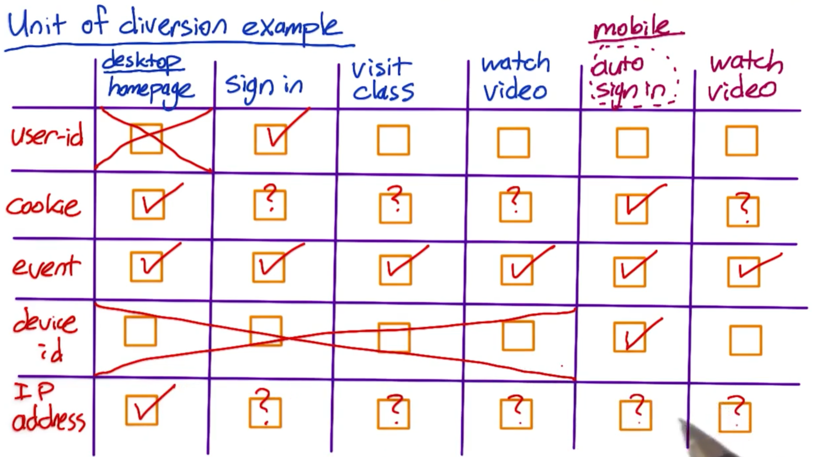

## Consistency of Diversion

Three main considerations when choosing unit of diversion-

* Consistency
* Ethical Considerations
* Variability

1. Consistency
   * + Mostly user ID or cookie is used
     + User visibility
     + The changes that are visible to users, should remain consistent
     + Changes like page ranking or latency are not visible to users

* What do you want to measure?
  + - Measure learning rate – use User ID
    - Making latency changes – user cookie or

## Consistency of Diversion: Example

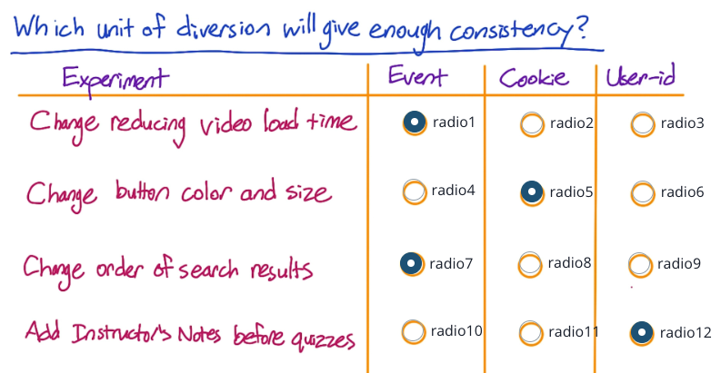

## Ethical Considerations for Diversion

1. Ethical Considerations
   * 1. If you use User ID then by definition the data is identified.
     2. In such cases you have to answer all the security & confidentiality questions
     3. You might need user consent
     4. Using cookies, user identity is not available, so these are less of issues

## Ethical Considerations: Example

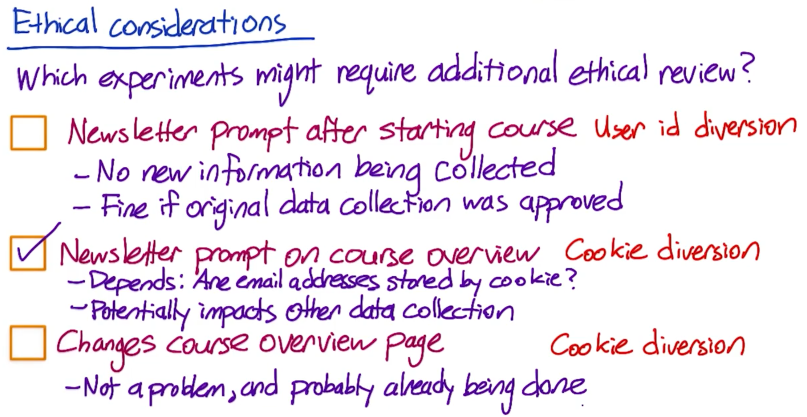

## Unit of Analysis vs Unit of Diversion

Unit of analysis – It is basically the denominator of your metric. In click-through-rate, page views is your unit-of-analysis.

Changing the unit of diversion can change the variaibility of a metric.

Example- Diana at Google found very different results using two unit of diversion- query and cookie.

* Diverting by query is a type of event based diversion, since for a search engine a query really is an event.
* The metric they measured was called coverage (% of queries for which an ad is shown)
* When you Unit of diversion and unit of analysis are tend to be same, then variability is smaller and closer to the analytical estimate than when they are different.

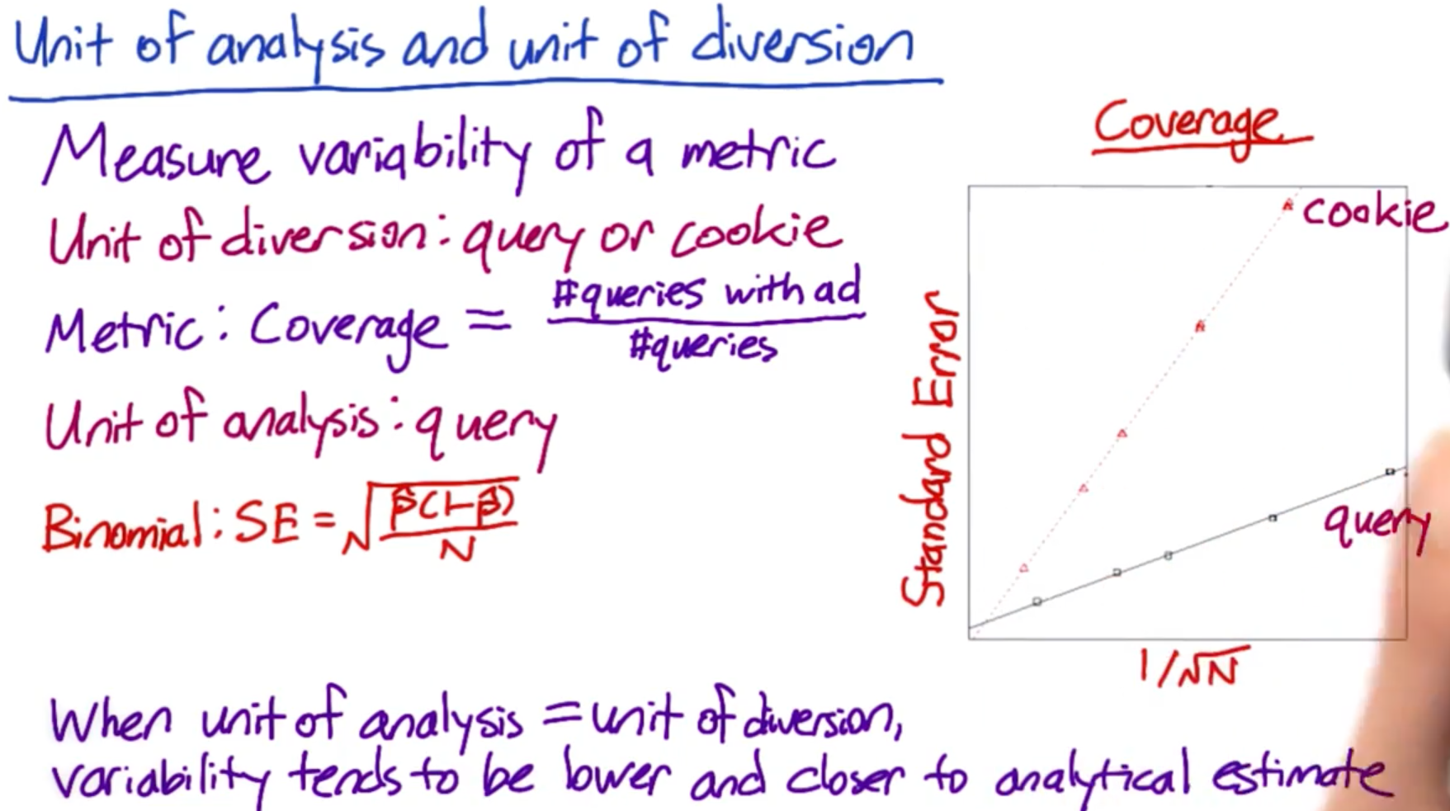

## Unit of Analysis vs Unit of Diversion: Example

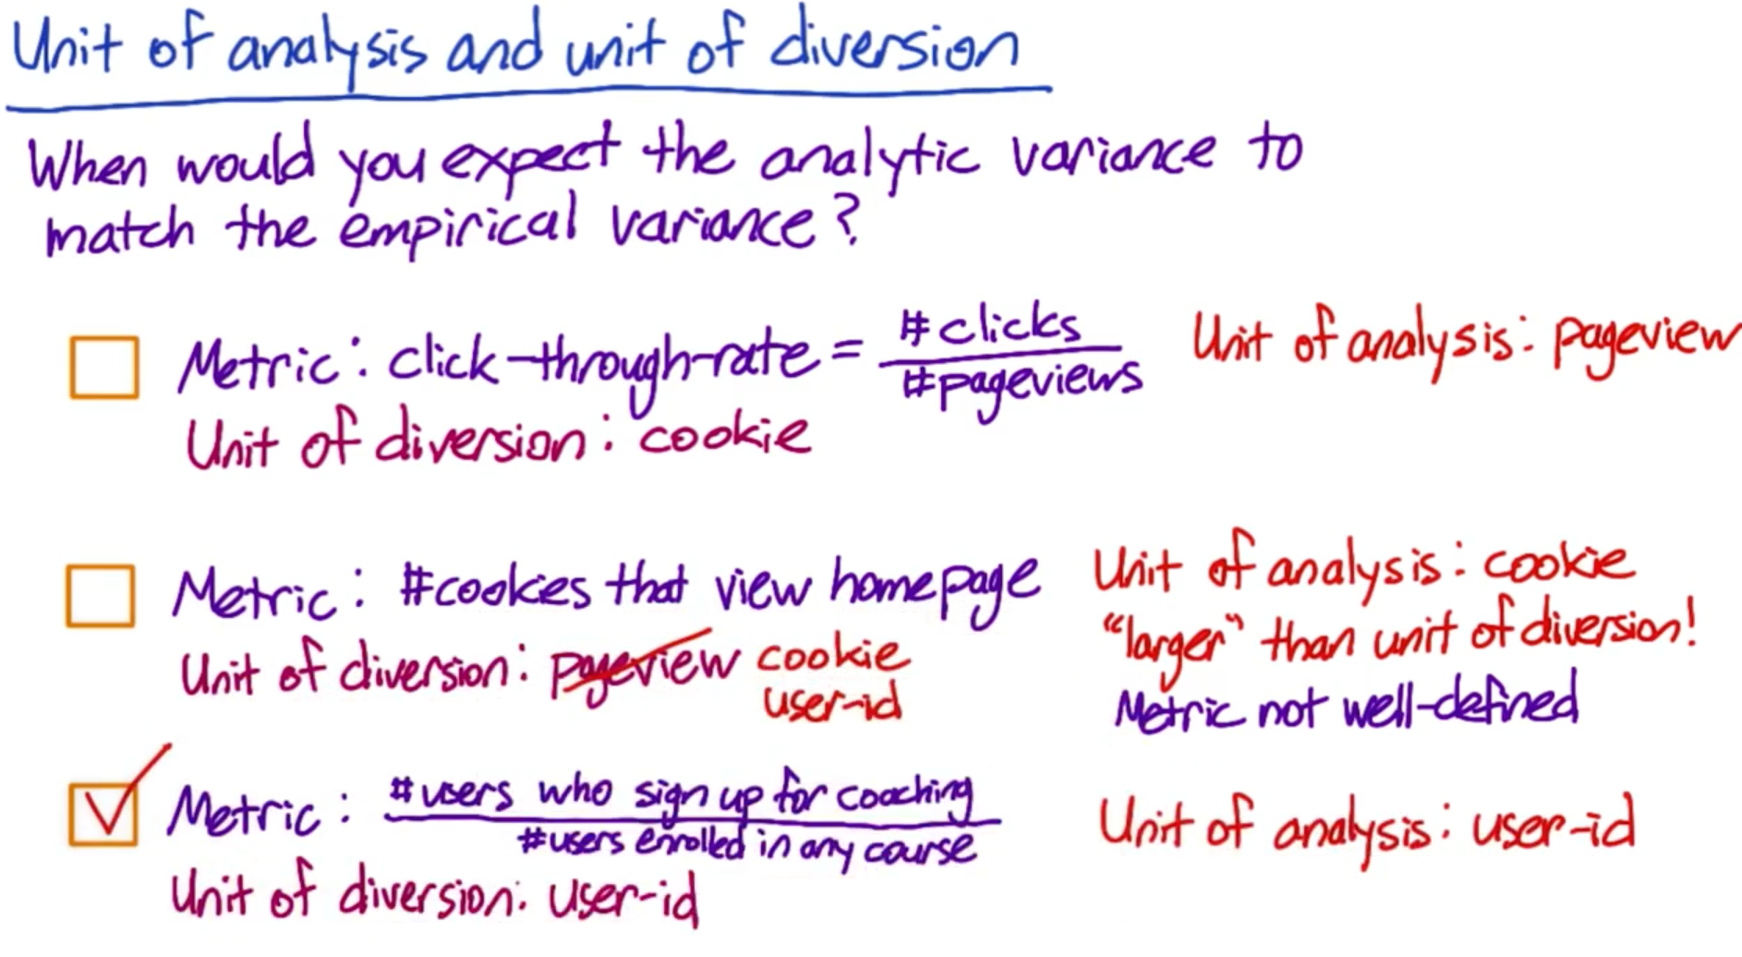

## Choose Population

## Inter-vs-Intra User experiments

Things to keep in mind for choosing Population

* Intra-user experiment
  + - You expose the same user to this feature being on and off over time
    - Then you analyze how they behave in different time windows
    - Have to be careful to choose a comparable time-window
    - Not do during festive seasons
    - People might have frustration, as they might get used to a feature and then the feature gets off
* Inter-leaved experiment
  + - You expose the same user to the A and the B side at the same time
    - It only works in cases where you are re-ordering a list
* Inter-user experiments
  + - This is mainly used in A/B testing
    - This means you have different people on the A side and on the B side
    - Refinement of this is called a cohort
* Cohort
  + - In a cohort, you try to match up your entering class so at least you have roughly same parameters in your two use groups
    - In medical and drug treatment trials. It needs paired group. Not generally seen in internet-based experiments.

**Interleaved experiments**

In an interleaved ranking experiment, suppose you have two ranking algorithms, X and Y. Algorithm X would show results X1, X2, … XN in that order, and algorithm Y would show Y1, Y2, … YN. An interleaved experiment would show some interleaving of those results, for example, X1, Y1, X2, Y2, … with duplicate results removed. One way to measure this would be by comparing the click-through-rate or -probability of the results from the two algorithms. For more detail see the link- <http://www.cs.cornell.edu/people/tj/publications/chapelle_etal_12a.pdf>

## Target Population

* Once Inter-user experiment is selected other reason to consider for target population
  + - Demographic reasons
    - Language they speak
    - Other features on websites that gives you target audience based on who you want to restrict who sees your experiment
    - If you can identify the population that will be affected by your experiment, you might want to target your experiment to that traffic. Else, it will have dilute effects.
* Also, before you launch a big change, you may actually want to go back and run a global experiment and make sure that you donot have unintensional effects on the traffic you weren’t targeting

## Target Population Example

* Filtering your traffic can also change your variability

Example-



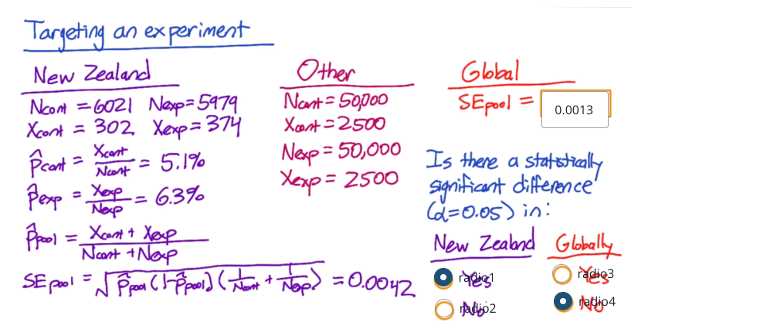

## Population vs Cohort

* In population you have a whole group of users.
* Within that population you cab define groups called cohort.
* Typically, this means people who enter the experiment at the same time.
* Cohorts are harder to analyze, they are going to take more data because you’ll lose users.
* You use Cohorts only when you are looking for user stability.
* You use cohort depending on the type of peroblem you are looking at

## Population vs Cohort: Example

* Cohort make more sense to use then entire population if
  + - Looking for learning effects
    - Examining user retention
    - Increase user activity
    - Anything requiring user to be established

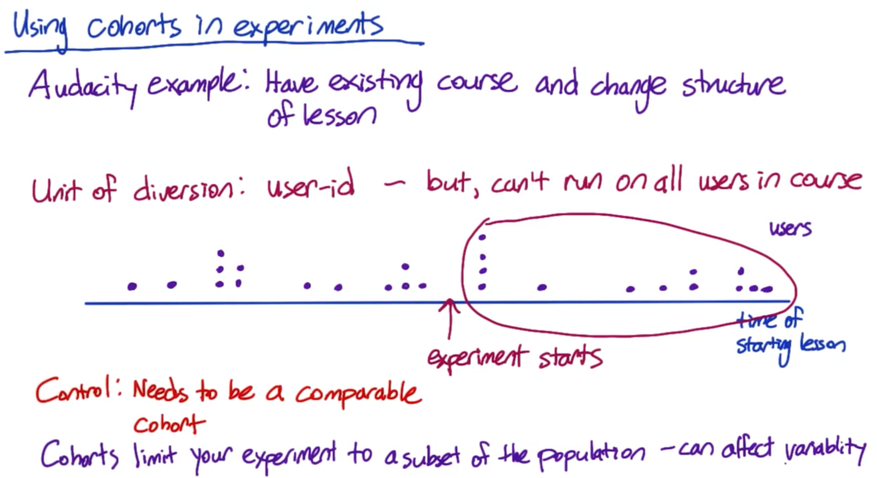

## Size

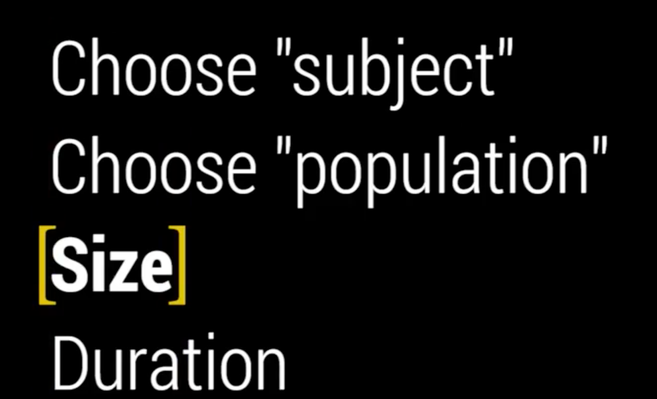

## Experimental Design and Sizing: Overview

* Next, we have to size our experiment and control
* This is an iterative process
  + - We try out some decisions for our unit of diversion and our population
    - Then see what the implication is on both the size as well as the duration of our experiment
    - And then, if we don’t like those results, we need to re-visit our decisions and iterate

## Sizing: Overview

* How to size our experiment based on practical significance, statistical significance and the sensitivity
* Things to look at
  + - Choice of metric
    - Choice of unit of diversion
    - Choice of population
    - All other things that can affect the variability of your metric

## Sizing: Example

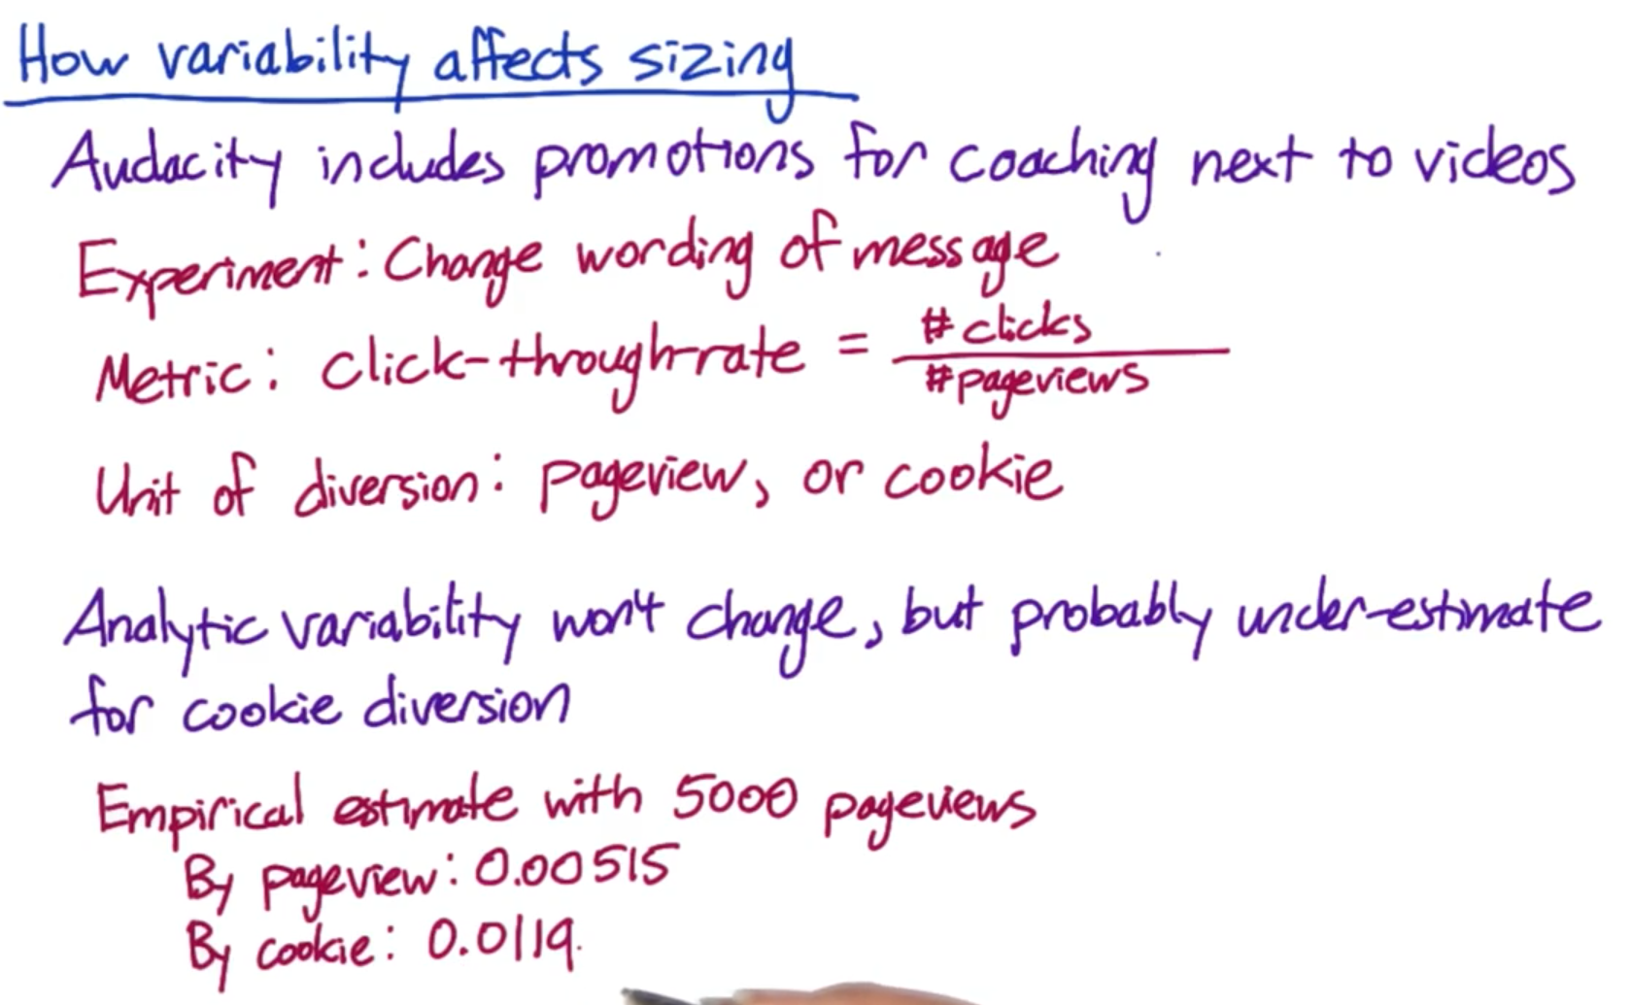

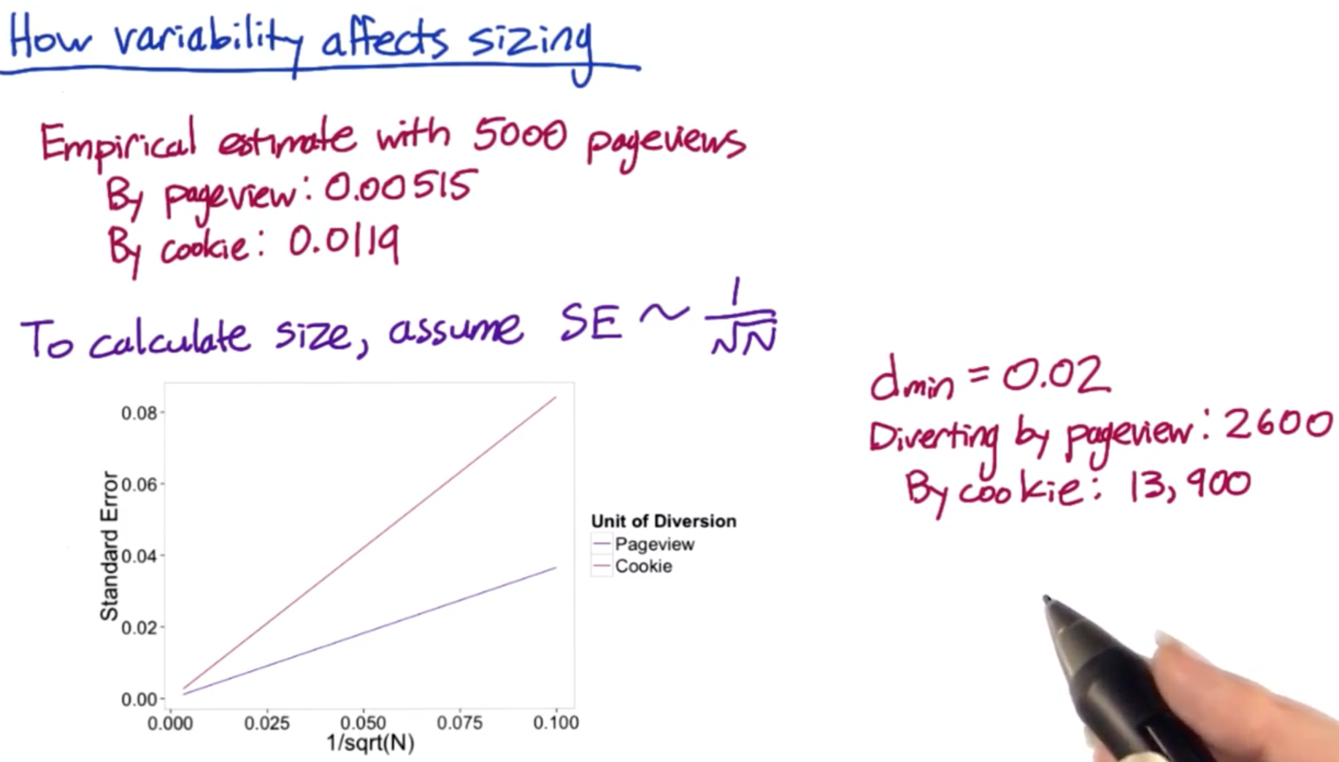

Sizing calculation R code link- <https://video.udacity-data.com/topher/2016/December/5845e980_empirical-sizing/empirical-sizing.r>

## How to decrease Experiment Size

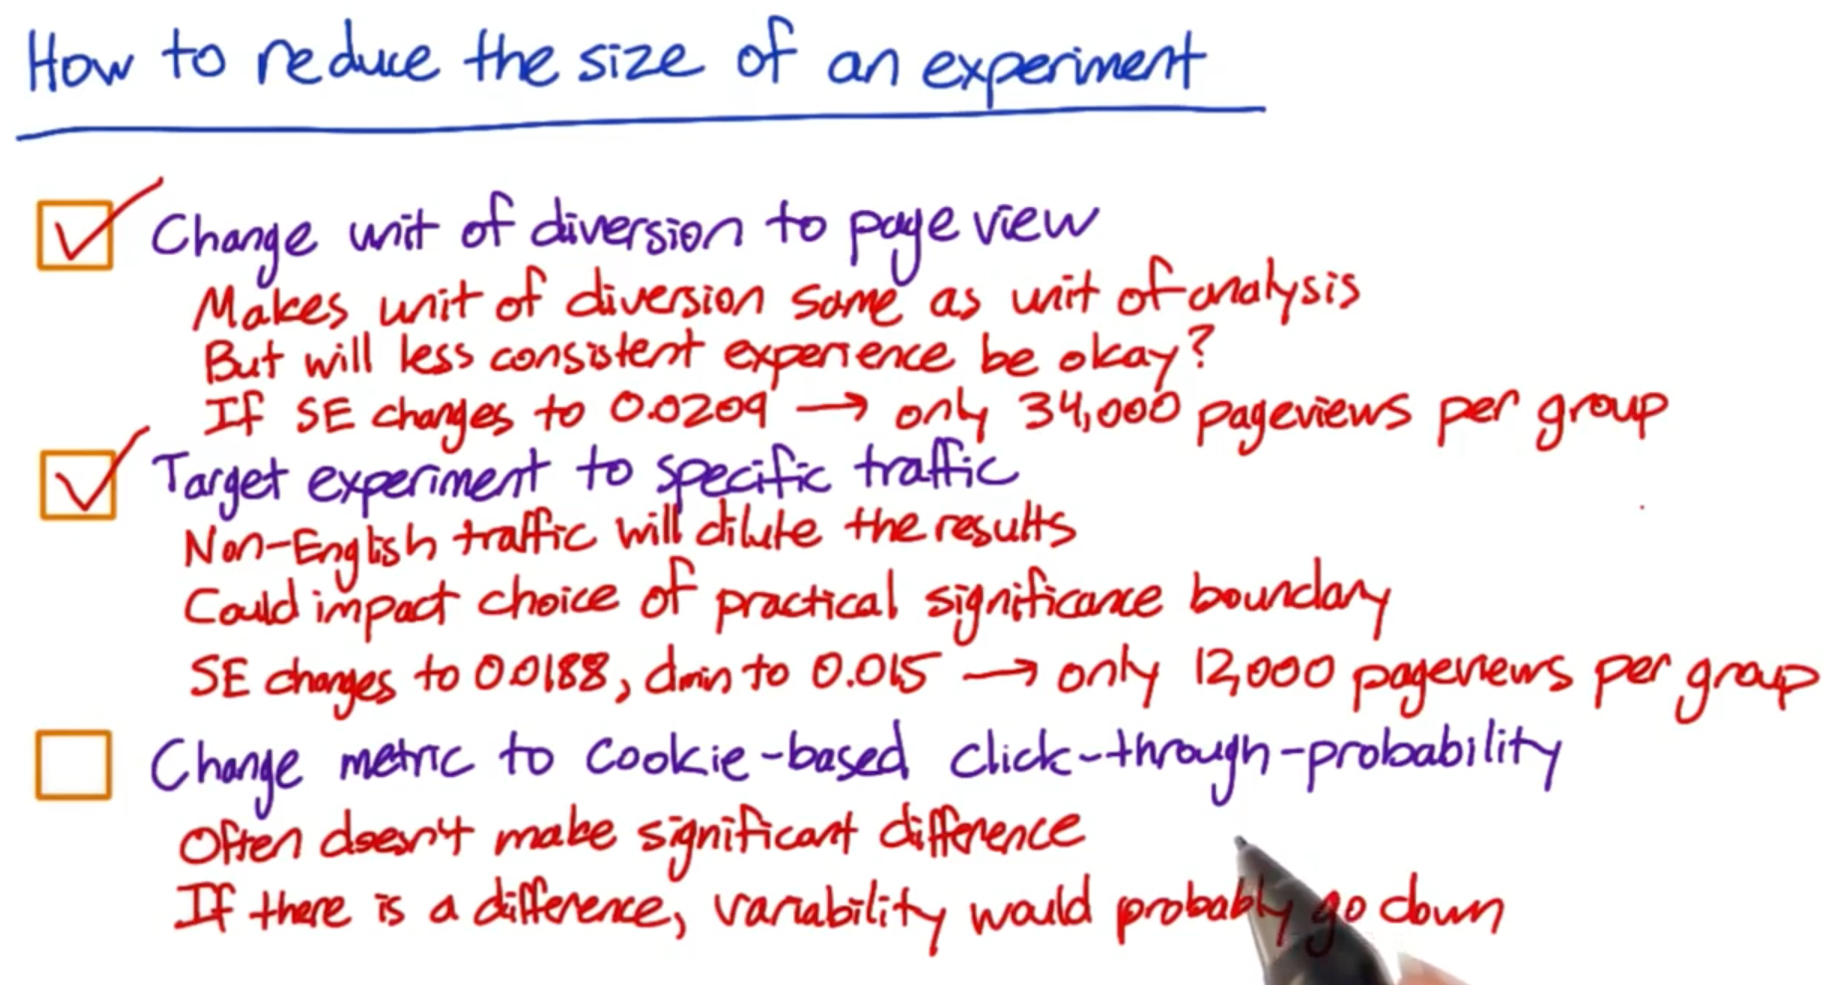

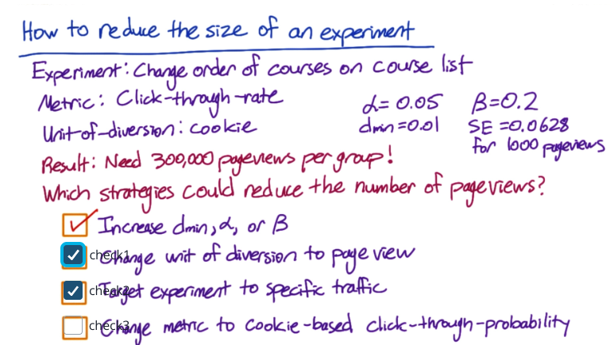

## Duration

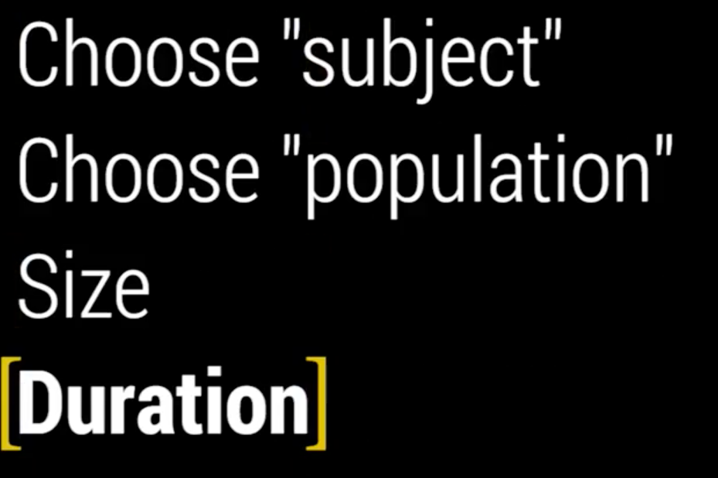

## Duration vs Exposure

* Duration of your experiment is related to the proportion of traffic that you’re sending through your experiment.
* You don’t run you experiments on all your traffic all together. You run them on smaller percentages of traffic. The reasons for that are-
  + - Safety
      * Example- you don’t know how your user is going to reach to a particular feature. So, only expose a few people to start with until you feel more comfortable.
    - Press
      * If a lot of people see the new feature, they would potentially blog about it
    - Include weekday- weekends, holidays

## Duration vs Exposure: Example

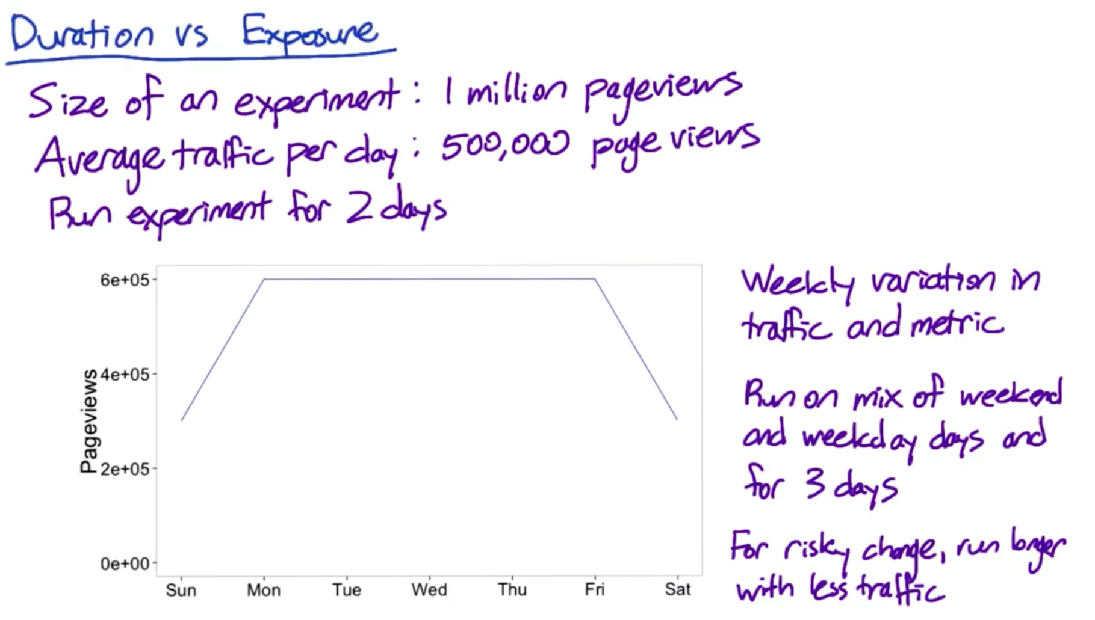

## When to limit exposure

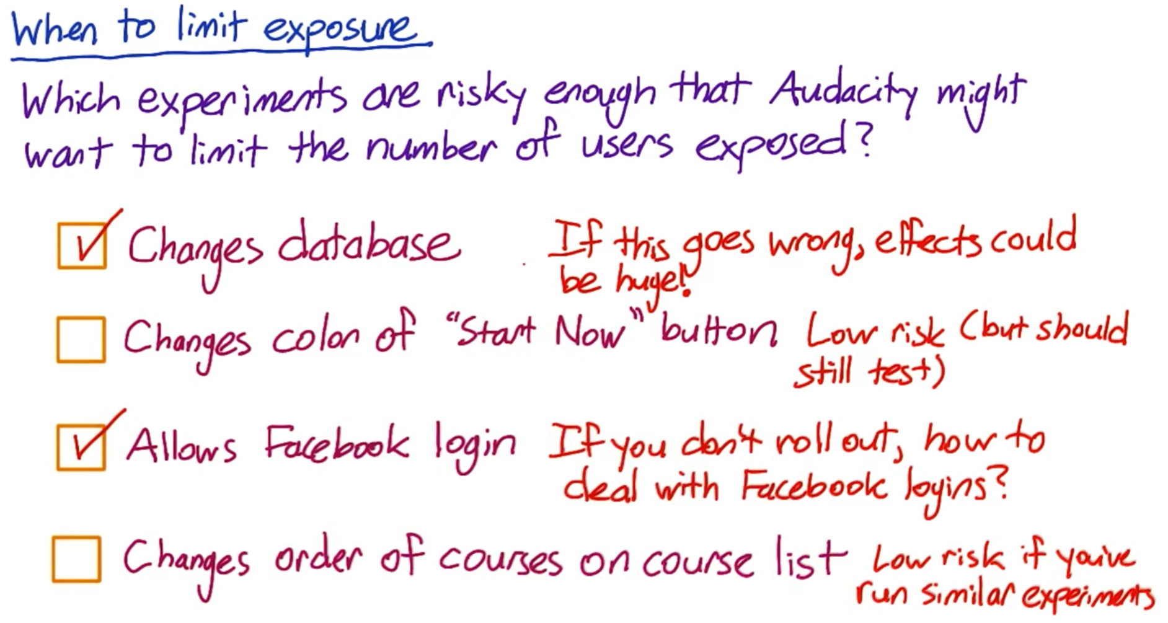

## Learning Effects

* Learning effects is basically when you want to measure user learning. Or effectively whether a user is adapting to a change or not.
* Two different types of learning effects
  1. Change aversion
     + User don’t like the changes in the version
  2. Novelty effect
* Key issue is “Time”, because user takes time to adapt with the change
* If there is enough time, then following things are important to consider
  1. Use a stateful unit of diversion like a cookie or a user ID
  2. A lot of learning is dependent on how often they see the change, also called dosage. Then, probably you want to use a cohort as opposed to just a population
  3. Risk and duration
     + It’s going to take a long amount of time
  4. Use analysis in pre-period and post-period. In the pre-period & post-period, expose the users in both control and experiment group the same content, essentially do A/A test.
     + A pre-period is before the experiment is run. If you experience any difference in the pre-period, then that difference is due to something else. Maybe be system variability, user variability
     + A post-period is after the experiment is run, we run another A/A test. If there are any differences in the experiment and control population, then I contributed the differences to user learning that happened in the experiment period.
     + These are advanced techniques.